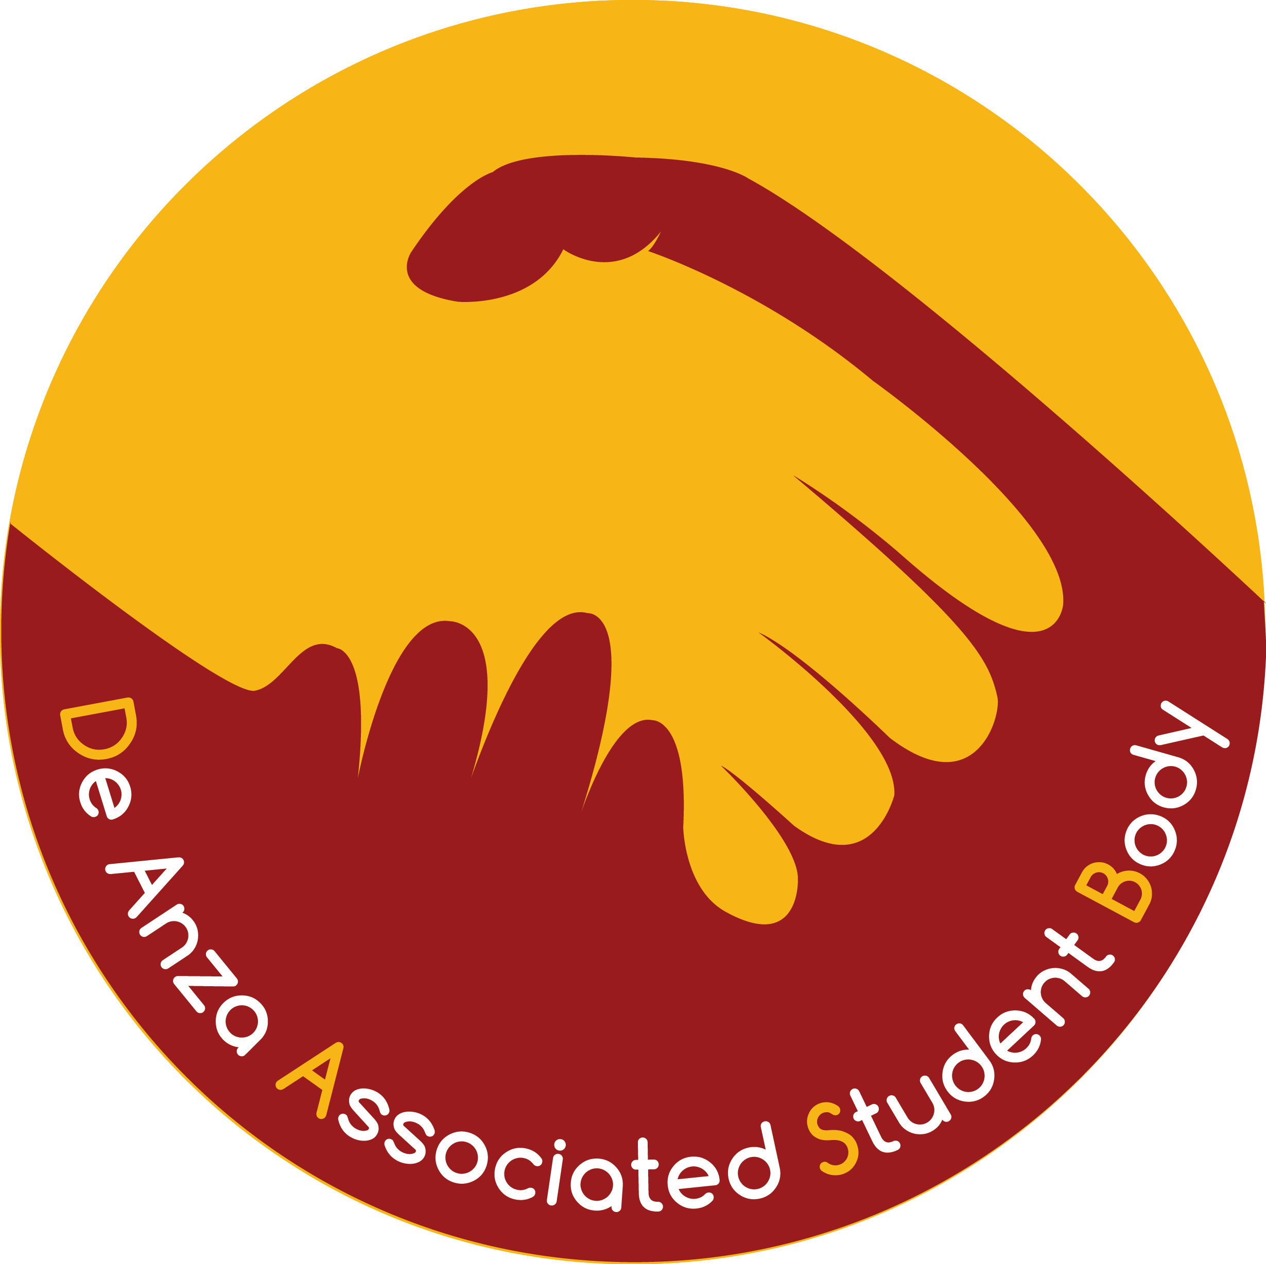 | De Anza Associated Student Body  Finance Committee Budget Bulletin  For Athletics  Amanda Le, DASB Chair of Finance  October 9, 2017

★ Keep this sheet for your reference. Do not copy/turn in with your application. 

The DASB is accepting requests for the 2018-2019 fiscal year budget. Use the attached application to request funding for the 2018-2019 fiscal year. If you have any questions, please contact Amanda Le, DASB Chair of Finance, at DASBFinance@deanza.edu, or Dennis Shannakian, College Life Office Coordinator, at 408-864-8757 or ShannakianDennis@deanza.edu.

DASB 2018-2019 ANNUAL BUDGET FUNDING REQUESTS

Welcome to Fall Quarter 2017

In the tradition of “Students Working for Students”, the De Anza Associated Student Body is beginning our annual budget process for the 2018-2019 academic year. Please read below for some changes that will be occurring for this funding cycle.

DASB funds are not intended to fund your entire program. Please be reasonable in your request.

- Any Request that is not fully completed will not be accepted.

- Any Request that is not in by the due date runs the risk of being rejected.

Signatures that are needed for requesting funds
All requests require the signature of the budgeter(s) and the administrator responsible for the program of the account. The budgeter and administrator responsible for the program of the account shall sign designating this is an appropriate expenditure of DASB funds and in the best interest of the student body. Administrators are responsible for any expenditures exceeding budget allocations. The Budgeter and Administrator cannot be the same person.

Budget Information Meetings
For questions regarding funding possibilities, procedures, requirements, etc. please go to a DASB Finance Committee Meeting, Mondays at 3:30 PM in Student Council Chambers A (HCC130).

2018-2018 DASB BUDGET CALENDAR

Monday, November 13, 2017 Budget Requests due to the Office of College Life by 4 PM
Fourteen (14) copies (ONLY) total are required (keep the original for yourself)

By Wednesday, February 28, 2018 Proposed 2018-2019 DASB budget posted on the DASB bulletin board located on
lower level of the Campus Center and online at www.deanza.edu/dasb/budget
Those requesting funds should review this draft.

By Wednesday, March 2, 2018 Final proposed draft presented to DASB Senate

Monday, May 7, 2018 DASB approved Budget presented to Board of Trustees for their approval.

Approved by DASB Chair of Finance | Produced by College Life/das - 8/7/2017

DASB Budget Request 2018-2019
For Athletics

Submit 14 copies (ONLY) total to the Office of College Life by Monday, November 13, 2017, 4:00 PM.

★ This form should be in front with any attachments stapled after it. 
PLEASE SAVE PAPER: Use the Word version of this form and delete the Object Codes and lines within Object Codes you do not need.
- Program (Account) Name:
- Is this a new DASB account? Yes  No  DASB Account Number:
- Amount requested for 2017-2018 $
- Total amount allocated for 2017-2018 $
- How long has this program existed?
- Number of students directly served in this program:
Please ACCURATELY and THOROUGHLY complete numbers 7 – 10 and use additional sheets if necessary.
- List ALL other accounts and/or sources of income (list ALL Account Numbers, Account Names, and Account Balances) also list ALL Co-Sponsorships for the Program; include anticipated future sources and co-sponsorships. Accounts and amounts will be verified.
Failure to disclose ANY and ALL non-DASB Funding Sources will result in the immediate disqualification of your request and/or the freezing of your DASB Account if already approved.
B Budget Accounts:
Trust Accounts:
Fund 15 Accounts:
FHDA Foundation Accounts:
Grant Funded Accounts:
Other District Accounts:
Off-Campus/Off-District Accounts:
On-Campus Co-Sponsorships:
Off-Campus Co-Sponsorships:
- Give a brief description of the program/services to be provided. How will these funds benefit present and future students?
- What would be the consequences if DASB didn’t fund or completely fund this request?
- How have you been meeting or how do you plan to meet the budget stipulation of requiring that all students benefiting from DASB funds allocated to you have paid the $10 DA Student Body Fee and are DASB Members (DASB Budget Stipulation # 1)?

- Total amount being requested for 2018-2019 (from page 2) $

PLEASE SAVE PAPER: Use the Word version of this form and delete the Object Codes and lines within Object Codes you do not need.

Dues and Membership Fees (5030)
Item Intended Use Cost
1.
2.
3.
4.
5.
TOTAL: $

Technical and Professional Services (5214)
(Independent Contractor amounts, Consultants/Guest Speakers/Entertainment (list programs).
For contracted speakers the fee shall not exceed $1,500 per speaker per event.
For performances the fee shall not exceed $2,000 per performance.)
Item Intended Use Cost
1.
2.
3.
4.
5.
TOTAL: $

Domestic Conference and Travel (5510)
(For away games, De Anza Athletic Teams are subject to a maximum allocation of $10 for breakfast, $12 for Lunch, and $15 for dinner per student athlete. Each student athlete is allowed a maximum of one breakfast, one lunch, and one dinner in a twenty-four hour period. Classifying the type of meal will be up to the discretion of the DASB Chair of Finance. The budgeter shall have the right to appeal the decision to the DASB Finance Committee.)
NOTE: Teams will be allocated a total sum only for away games and contests travel in California. Teams may use some of this funding for games and contests out of California by requesting a waiver from the DASB Finance Committee during the fiscal year of the budget.

Item Intended Use Cost
1.
2.
3.
4.
5.
TOTAL: $

Capital (6420)
(Any durable item whose value exceeds $500 and has usable life of one (1) year or more)
Item Intended Use Cost
1.
2.
3.
4.
5.
TOTAL: $

Total amount requested (also complete line 11 at bottom of first page) $

Income Commitment (if required) $

PLEASE SAVE PAPER: Use the Word version of this form and delete the Object Codes and lines within Object Codes you do not need.

Signatures that are needed for requesting funds
All financial documents, forms, requests/requisitions require the signature of the budgeter(s) and the administrator responsible for the program of the account. The budgeter and administrator responsible for the program of the account shall sign designating this is an appropriate expenditure of DASB funds and in the best interest of the student body. Administrators are responsible for any expenditures exceeding budget allocations. The Budgeter and Administrator cannot be the same person.

Budgeter’s Name: (print)
Budgeter’s Signature:
Phone Extension:
E-mail:
Relationship to Project:
Position on Campus:

Administrator’s Name: (print)
Administrator’s Signature:
Phone Extension:
E-mail:
Relationship to Project:
Position on Campus:

Approved by DASB Chair of Finance (Produced by College Life/das - 7/3/2017)

PLEASE SAVE PAPER: Use the Word version of this form and delete the Object Codes and lines within Object Codes you do not need.

