DE ANZA COLLEGE
BUSINESS, COMPUTER SCIENCE & APPLIED TECHNOLOGIES DIVISION
BUSINESS 10 - INTRODUCTION TO BUSINESS
Winter 2018 – Section 4Y CRN: 30217
INSTRUCTOR: Emily Garbe, PhD

Welcome to Introduction to Business! This is a hybrid class where we will have face-to-face meetings two days a week plus online assignments and activities. We will cover the basics of businesses, so get ready for a fun and exciting quarter!

The assignments and deadlines are listed at the end of this syllabus, but are subject to change based on the course progress during the quarter. The instructor will make a class announcement should there be any changes to the syllabus.

Please read this document carefully as information you seek about the course process and structure should all be in this syllabus, Canvas home page, FAQs on Canvas course page, or the assignment descriptions in Canvas weekly assignment areas. Note that in this document, all URL links are embedded and designated with the names of the sites underlined. Please click on all underlined words to access the corresponding external links.

NUMBER OF UNITS: 5

ADVISORY:
English Writing 211 and Reading 211 (or Language Arts 211), or English as a Second Language 272 and 273.

STUDENT LEARNING OBJECTIVES:
By the end of the course, students are expected to:
- Distinguish among the primary functions within a business, (i.e., marketing, operations, human resources, accounting and finance) and identify the interests and roles of key business stakeholders (i.e., employees, management, owners, and society).
- Demonstrate a working vocabulary of business terms.

CLASS INFORMATION:
Class hours: Monday/Wednesday 11:30 am-1:20 pm
Class location: ADM102

INSTRUCTOR CONTACT INFORMATION:
- Office hours: M-R 10:30-11:20 am (no appointments needed)
- Office location: Business lab (ATC 203D – enter from outside door only, not through CIS Lab)
- Contact the instructor via Canvas Messaging (please do not use email or the comment fields with an assignment). The instructor will try to answer the messages within 48 business hours or likely much sooner.

CLASS MATERIALS:
- Textbook: Better Business, 5th ed, by Solomon, Poasty & Martin.
- Pearson MyLab
- Test supplies: 4 Scantron Score Sheets (Form 882E, 4”x11” green) and #2 pencils. Scantron score sheets are available at the De Anza bookstore.

There is a new process for purchasing Pearson etext and MyLab materials called "DDR" (Direct Digital Access). At the start of the quarter, students automatically have access to etext/MyLab via Canvas by entering the access code listed below. Students then have 2 weeks to pay for the materials otherwise their accounts will be cancelled by the Bookstore.
Students can pay for the materials by either (1) going to the De Anza Bookstore in person, or (2) buying from the De Anza bookstore website online. Note that the $69 is a special negotiated price only from the De Anza bookstore. The printed textbook priced at $60 is optional as an add-on to the ebook/MyLab. Access codes purchased from Amazon and other websites would not work since this material is specifically for this course only.
To purchase, please follow the steps below:
- At the start of the quarter, log into your De Anza College Canvas Account and select “BUS 10 Sec 4Y”. Canvas homepage is available at the start of the quarter.
- Select “MyLab & Mastering” from the left-hand menu, then select “Open MyLab” option in the center of your screen.
- Enter your Pearson MyLab username and password. If you have used a Pearson product previously, such as MyMathLab, MyEconLab, etc, then use the same user name and password. If you are new to Pearson MyLab, then select “Create” and follow the instructions.
- Select “Access Code” after login, and enter code: MYBIZE-BAZOO-CURCH-ACERB-ELVIS-FAMES. You can now access MyLab and etext. This code will be revoked by the De Anza bookstore/Pearson if you do not pay for the material by the drop date.
- Next, you need to pay for the materials. If you would like to pay online, click on this bookstore link. If you would like to purchase in person, or if you are using financial aids, please go to the De Anza bookstore, not the instructor. You will also need to fill out an “opt-in” form” in person at the bookstore.
- Accounts not paid by the drop date 1/21/18 will be automatically deleted by Pearson. Do not contact the instructor regarding any payment or financial aids since the instructor has no role in account creations, payments, or account deletions. All students whose access are revoked by the De Anza Bookstore will be dropped from the course by the instructor upon notification by the Bookstore (which means no refund for the course since this would occur after the De Anza deadline for refund.)

COURSE ACTIVITIES:
- Chapter reading
- In-class mini-sims
- In class projects
- Online chapter quizzes
- Tests and Final Exam

The instructor has set up direct seamless links to each assignment from Canvas course page. Please access the assignments by clicking on each of the assignment link in Canvas weekly assignment area, not from Pearson website.
You will need to access the websites listed below:
- All registered students must use De Anza’s courseware Canvas to access the course homepage where access to all the course materials reside.
- Read the lecture slides for the assigned chapters. You may want to print out the lecture slides, and use them as the study guide for the chapters.
- Read the etext by clicking on the MyLab tab at Canvas course homepage.
- Complete the mini-sim(s) for the assigned chapters I class with your group. Make sure you enable Java and cookies in your browser. Access mini-sims from Canvas weekly assignment area.
- Take the open-book online chapter quizzes only after you have studied the chapters.

GETTING HELP:
Please click on the help button on the lower left of your Canvas screen for tech support, or upper right hand corner “?” for Pearson MyLab help desk. Please do not ask the instructor for tech support since the Pearson and Canvas are much better positioned to help you.

For questions about course contents, please come to the instructor’s office hours in the Business Lab (ATC203D). Or you can contact the instructor via Canvas Inbox (not via email), so we can keep track of all communications.

SYSTEMS AND NETWORK REQUIREMENTS:

Access to a computer and the Internet:
This is a hybrid class, which means part of the coursework will be completed online.

A computer is required for submitting your assignments. You may use your own computer for Internet access; or, if you prefer, you can use the computers in either the De Anza library or the Library West Computer Lab. Hand-written papers will not be accepted. Not having time to go to the library to use the computers or forgetting to do the assignments is not a valid excuse for incomplete assignments.

No late submissions or re-grading of assignments will be permitted since answers are made available after the due dates. No exceptions.

Canvas:
Canvas supports the current and first previous major releases of the following browsers:
- Internet Explorer 11 and Edge (Windows only—please make sure your operating system is also current as noted in the computer specifications lesson; you may need to download the Windows 10 Anniversary Update to submit Canvas assignments)
- Safari 8 and 9 (Macintosh only)
- Chrome 52 and 53
- Firefox 47 and 48 (Extended Releases are not supported)
- Flash 22 and 23 (used for recording or viewing audio/video and uploading files)

We highly recommend updating to the most current version of your preferred browser. Your browser will notify you if there is a new version available.
Run the readiness test by clicking on this link so that you can test your browser and see what plug-ins you might need.

Pearson Mylab/etext:

Pop-up, Java and cookies need to be enabled to view the videos and run the simulations. For Google Chrome, go to “setting”, “advance setting”, “privacy”, “content setting”, “pop ups”, “allow”. For more details or for other browsers, please follow this link to make sure your computer support Pearson MyLab. You must also enable cookies. Follow the instructions listed in this link very carefully and do exactly what was recommended for popups and cookies. You must enable both. For cookies, include “pearson.com”, “pearsoned.com” and “mathxl.com” in “Manage exceptions” of cookies settings. The Pearson link above has detail instructions and screen shots to guide you. For instructor’s own experience, Safari on Apple and Firefox on Windows seem to run better. However, Pearson recommends IE or Chrome. Please try different browsers to see which runs best on your own system. If that does not work, try another computer.

Not able to see the etext, quizzes, or sims are not valid reasons for missing assignments. Again, please contact Pearson help desk if you have any technical issues, not the instructor.

Course Home Page:
Log into Canvas at with your De Anza ID. You can access your Canvas course home page at the start of the quarter.
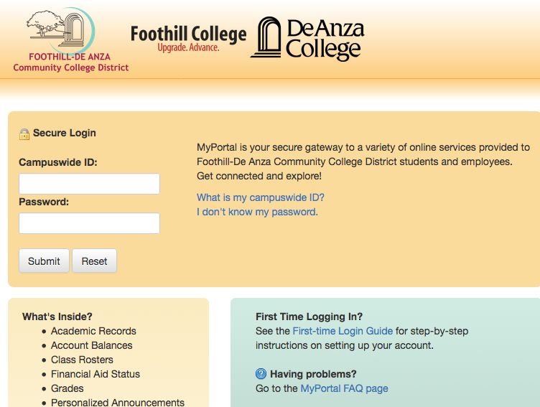

Once you log in to Canvas, you will see a list of courses you have registered that has a Canvas component. Click on BUS90 to go to our course home page.

Click “MyLab and Mastering” for etext.

Click on the appropriate week button for each week’s assignment module.
Click on “Grades” to keep track of your own progress.

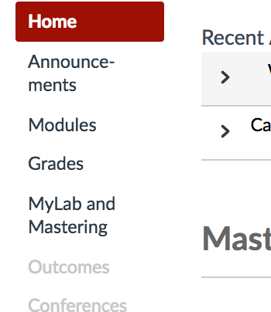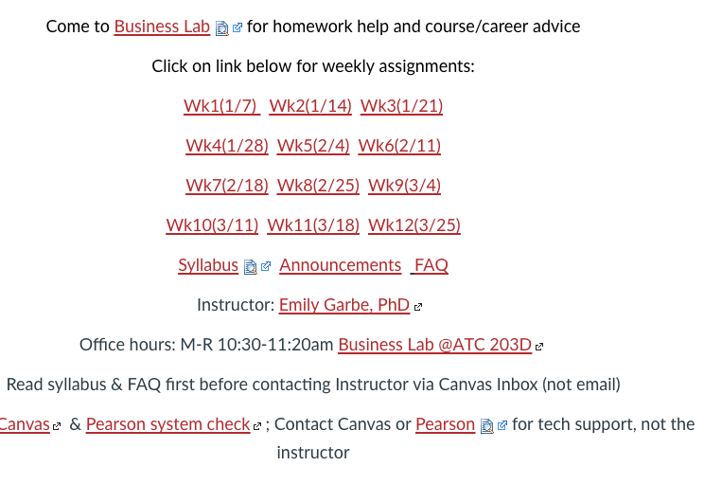
Within each week’s module, there are two sections: Resources and Assignments. Follow the list under Resources for chapter readings, lecture slides, and any additional videos or weblinks. Chapter readings for our main textbook reside on Pearson MyLab. You can click on “MyLab” then “etext” to access the textbook. You can also download the Pearson etext app onto a mobile device and read your chapters on the mobile device. However, you need to complete and submit the assignments on a computer, not a mobile device.
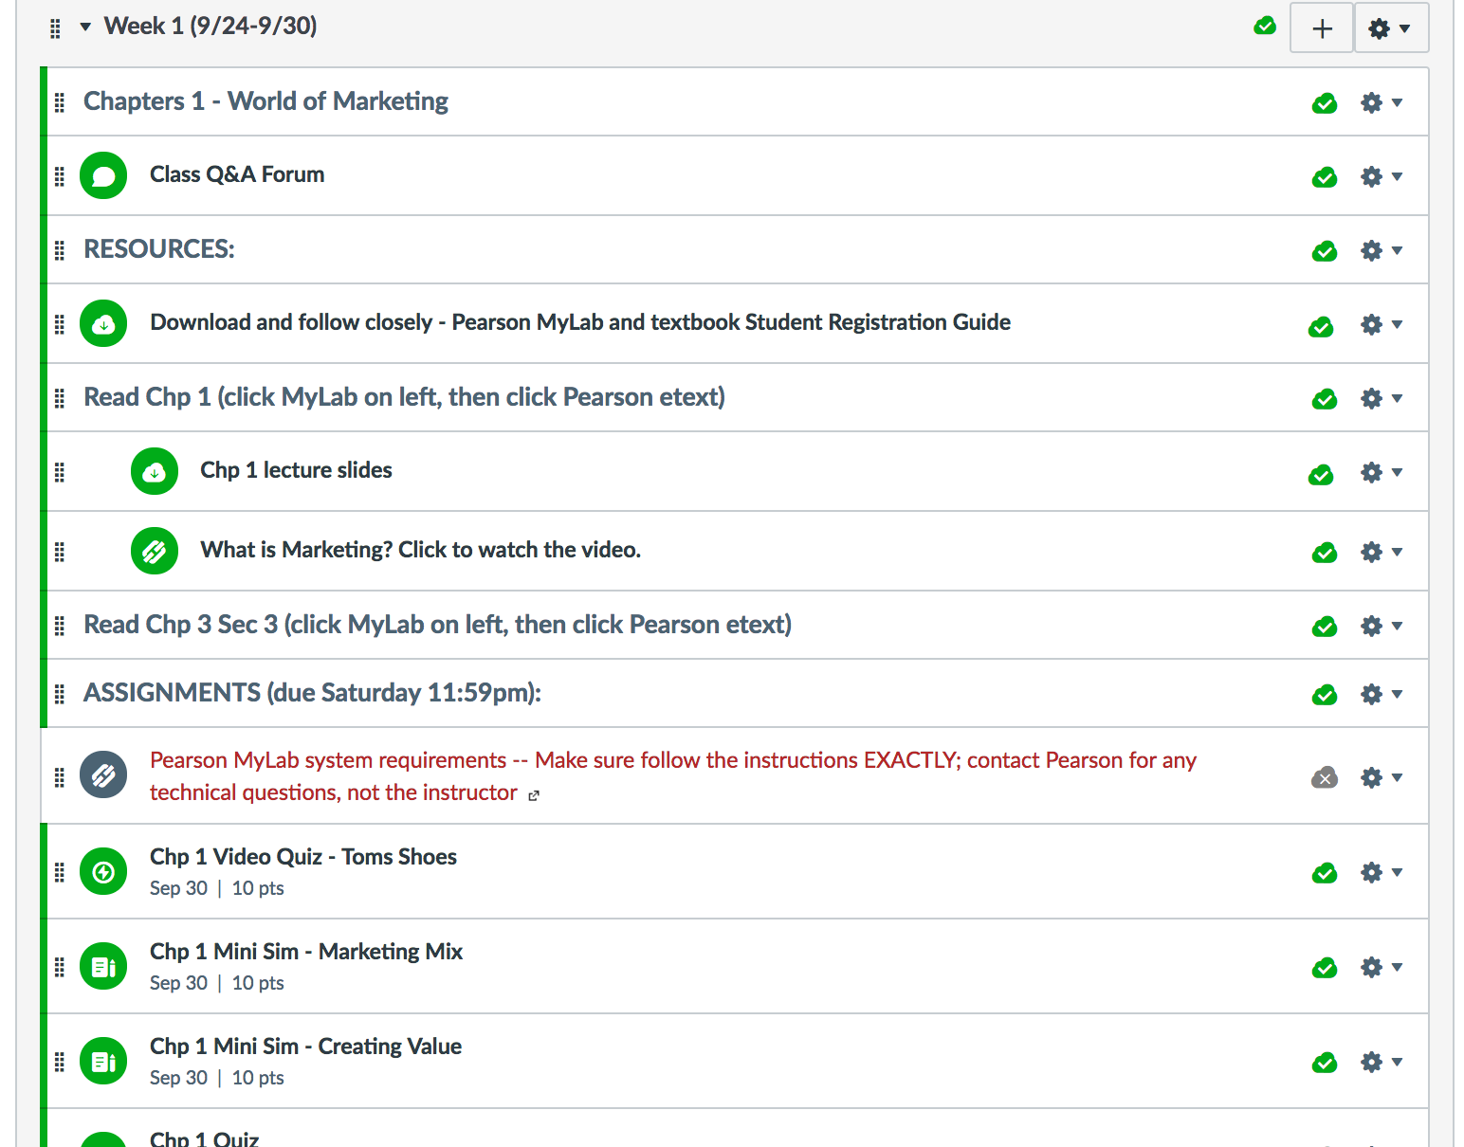

All assignments are due either in-class or on Saturday 11:59pm. Complete each assignment by clicking on each mini-sims and chapter quiz links which will seamlessly take you to Pearson MyLab. Grades from MyLab will be transferred to Canvas grade book after the due date.

CLASS ATTENDANCE AND PARTICIPATION:
You must be officially registered in the class to attend classes and submit assignments. Attending classes and/or submitting assignments without official registration in the class are invalid and prohibited, and do not constitute registration in this class.

To avoid being dropped from this course for inadequate attendance and participation, student must:
- Attend first day of class
- Attend at least 2 face to face classes by end of Week 2nd
- Miss no more than 2 weeks of classes
- Purchase the textbook/MyLab by the drop date
- Take all 3 tests

Instructor reserves the right to drop all students who miss more than 2 weeks of classes or miss one or more tests.

Online quizzes are available two weeks ahead of the due dates as listed at the end of this syllabus; please plan your time accordingly and work ahead – do not wait till the due date. Since the assignments and readings are available 7x24 online (accessible anytime anywhere) two weeks in advance, the only valid reasons for late submissions or requesting an Incomplete for the course are major medical emergency/hospitalization (yourself or child/significant other), National Guard, or jury duty/court appearance, all with official proofs. Travel, work schedule, non-emergency/non-hospitalized illnesses, family matters, vacation, forgetting, work conflicts, busy with another class, and personal issues are not valid reasons for not submitting the quizzes.

Important note: If you have a busy school week ahead, or have frequent, persistent, or high likelihood of family issues or work conflicts, please complete the assignments early rather than waiting until the due dates. You have 14 days to find time for your reading and quizzes. However, if two weeks in advance is not sufficient, please let the instructor know so that accommodations can be made to fit your needs.

There are free passes for a mini-sim and chapter quizzes to cover assignments you may have missed.

Timely completion of assignments is essential as learning in this class is built on top of the previous chapters. As such, for those students who add the class with an add code, the record of assignment submissions and participation maintained by the instructor begins with the day the students are given the add code by the instructor.

Based on the De Anza Student Handbook, to request an incomplete on the transcript, a student must have completed at least 75% of the course assignments. If a student wants or needs to drop the class, the student is solely responsible for dropping the course. See De Anza’s policies and deadlines for attendance and drop/add/withdraw calendar.

If you miss a class, please go to Canvas and download the lecture slides. In-class assignments will need to be submitted end of class. No late assignment submissions regardless of reasons except for jury duty, National Guard or major medical emergencies, all with official proofs.

Use of computers in class:
Please note that there will be in-class assignments that require a laptop. However, students will work in groups so please join a group where a member already has a laptop.

ASSIGNMENTS AND GRADES:

Online chapter quizzes
All online chapter quizzes must be completed by 11:59 pm of the due date. These are open-book, open-notes assignments to be completed on Canvas. Make sure to hit “submit” to receive the grades for your assignments. Once you start a quiz, you must complete it. There is no restart or pause on the timer. Please note that each quiz question is on a new screen, as such it is impossible for you to progress through a quiz without the system recording your work on each question; as such, it is not possible for the system to fail to register your work.

In class assignments
All in-class mini-sims and projects are due the end of class periods. There is no late submission. Students who are not present or join the class late cannot claim to have participated in the assignments after class. Participation is based on when the instructor takes attendance at the time of the instructor’s discretion during the class period.

Tests and final exam
There will be three in-class, closed-book, closed-notes tests plus a final exam. No phones, notes, or personal items allowed. Students must have official photo ID to take the tests and exam. Please note that DeAnza Academic Integrity policy will be strictly enforced.

Extra credits
At the discretion of the instructor, and if time permits, instructor may provide extra credit opportunities based on current events and class participation.

Grading
College professors do not give grades; students earn them. Below is a breakdown of the points from assignments and tests for students to earn.
Note that Canvas will drop lowest grades assignments per the table below at the end of the quarter. So if you did not do well in one or two assignments, had systems issues, or forgot/missed them, do not panic and never ask the instructor to extend or restart for you as it would not be fair to others in the class.

 | Canvas points | % of total
In class Mini Sims | 100 points (11 sims, 10 points each, 1 lowest grade dropped) | 5%
In class projects | 100 points | 5%
Online chapter quizzes | 300 points (14 chapters, 25 points each, 2 lowest grades dropped) | 15%
Test 1 | 330 points (66 questions, 5 points per question) | 16.5%
Test 2 | 355 points (71 questions, 5 points per question) | 17.75%
Test 3 | 315 points (63 questions, 5 points per question) | 15.75%
Final exam | 500 points (100 questions, 5 points per question) | 25%
Total | 2,000 points required to get 100% | 100%

Letter grades will be assigned to students based on their total points, which is calculated as a sum of the grading components, as described above, divided by 2,000 points.

The following table for letter grades is finite and not negotiable. To be fair to your fellow classmates, do not ask the instructor to change the cutoff for the letter grades for you.

Total % | Letter grade
97% or above | A+
93%-96.9% | A
90%-92.9% | A-
87%-89.9% | B+
83%-86.9% | B
80%-82.9% | B-
77%-79.9% | C+
70%-76.9% | C
67%-69.9% | D+
63%-66.9% | D
60%-62.9% | D-
59.9% or below | F

ACCOMMODATIONS:
Students with learning disabilities are encouraged to make arrangements with the De Anza Disabled Student Services DSS if you need extra time on the quizzes. Students who are unsure whether they have a learning disability are encouraged to contact the Disability Programs and Support Services as soon as possible to determine eligibility. Please submit your DSS form to the instructor if you need accommodations. Instructor cannot make accommodations without written instructions from DSS.

Pearson MyLab and Canvas provides accessibility accommodations for all etext, sims, and quizzes. Please follow the instructions as indicated by Pearson and Canvas.

ACADEMIC INTEGRITY:
Students are expected to abide by the Student Conduct Rules as described in the Student Handbook. For all assignments, tests, and final exam, never copy any materials from another student, or from the Internet. Any assignments with un-cited materials copied from the Internet, another De Anza student (current or prior students) or students from another college as determined by the instructor or turnitin.com will be viewed as plagiarism and will be immediately referred to De Anza’s Dean of EOPS & Student Development for actions.

Students must complete their own assignments. Students who lie to the instructor or are disrespectful to fellow students or the instructor will be immediately referred to the Dean for disciplinary actions.

Business 10 Section 4Y – Winter 2018

Date | Topics | In-class Activities (due end of class) | Online Assignments (due 11:59 pm Saturday)
Week 1:  Jan 8 | Introduction  Chapter 1 – Business Basics
Jan 10 | Chapter 1 video – Muttville  Chapter 12 Marketing & Consumer Behavior
Week 2:  Jan 15 | 1/15 MLK day - Holiday | No class
Jan 17 | Chapter 12 video – Jones Soda  Syllabus overview  Chapter 13 – Product Development, Branding, and Pricing Strategies | Chp 12 mini-sim – Marketing  Review setup for Canvas and Pearson MyLab  Pearson presentation  Finalize seating chart | Chapter 1 quiz  Chapter 12 quiz
 | 1/21 Last day to pay for textbook, or to drop the class
Week 3:  Jan 22 | Chapter 13 – Product Development, Branding, and Pricing Strategies (cont’d)  Chapter 13 video – DC Shoes | Chp 13 mini-sim- pricing | Chapter 13 quiz
Jan 24 | Chapter 14 – Promotion and Distribution  Chapter 14 video – Pet Food Express | Chp 14 mini-sim | Chapter 14 quiz
Week 4:  Jan 29 | Test #1 (chapters 1, 12, 13, 14) | Bring Photo ID, Scantron & #2 pencils
Jan 31 | Chapter 15 – Financing and Accounting for Business Operations  Chapter 15 Video - Witness.org
Week 5:  Feb 5 | Chp 15 (con’td)  Apple Worksheet | Chp 15 Mini-sim – Accounting  Print out Apple financial worksheet and complete; due in class | Chapter 15 quiz
Feb 7 | Instructor in conf 2/7-2/8 | No class
Week 6:  Feb 12 | Chapter 11 – Production, Operations and supply Chain Management  Chapter 11 video – Operations Management  Business Insurance |  | Chapter 11 quiz
Feb 14 | Chapter 7 – Business management and Organization  Chapter 7 Video -MyGym | Chp 7 Mini-sim - Plan  Chp 7 Mini-sim - organizing | Chapter 7 quiz
Week 7:  Feb 19 | 2/19 Pres. Day Holiday | No class
Feb 21 | Test 2 (Chapters 7, 11, 15) | Bring Photo ID, Scantron and #2 pencils; calculators will be provided during the test
Week 8:  Feb 26 | Chapter 6 – Forms of Business Ownership  Chapter 6 Video-DBA LLC |  | Chapter 6 quiz
Feb 28 | Chapter 5 – Small Business and the Entrepreneur  Chapter 5 Video– Wild Planet | Group Venture PowerPoint due in class | Chapter 5 quiz
 | Fri 3/2 last day to withdraw
Week 9:  Mar 5 | Chapter 2 – Economics and Banking  Chapter 2 Video - Banc First | Chp 2 mini-sim – Supply and Demand | Chapter 2 quiz
Mar 7 | Chapter 4 – Business in a Global Economy  Chapter 4 Video - Gawker Media | Chp 4 Mini-sim – Going global | Chapter 4 quiz
Week 10:  Mar 12 | Test 3 (chapters 2, 4, 5, 6) | Bring Official Photo ID, Scantron and #2 pencils
Mar 14 | Chapter 8 – Motivation  Chapter 8 video-Whole Foods | Chp 8 Mini-sim - Motivation | Chapter 8 quiz
Week 11:  Mar 19 | Chapter 9 – Human Resource Management  Chapter 9 video - Patagonia | Chp 9 Mini-sim - HRM | Chapter 9 quiz
Mar 21 | Chapter 3 – Ethics in Business | Video case study & discussions– Brain hacking  Chp 3 Mini-sim - ethics | Chapter 3 quiz
Week 12:  Mar 26 (M) | Final Exam 11:30 am-1:30 pm (Chapters 1-9, 11-15) | Bring Scantron, De Anza Photo ID, and #2 pencils
** Please note that due dates may be modified during the quarter and will be announced in class or on Canvas.

De Anza College DSPS Syllabus Statement

De Anza College views disability as an important aspect of diversity, and is committed to providing equitable access to learning opportunities for all students. Disability Support Services (DSS) is the campus office that collaborates with students who have disabilities to provide and/or arrange reasonable accommodations
- If you have, or think you have, a disability in any area such as, mental health, attention, learning, chronic health, sensory, or physical, please contact DSS to arrange a confidential discussion regarding equitable access and reasonable accommodations.
- If you are registered with DSS and have accommodations set by a DSS counselor, please be sure that your instructor has received your accommodation letter from Clockwork early in the quarter to review how the accommodations will be applied in the course.
Students who need accommodated test proctoring must meet appointment-booking deadlines at the Testing Center.
- Exams must be booked at least five (5) business days in advance of the instructor approved exam date/time.
- Finals exams must be scheduled seven (7) business days/weekdays in advance of the instructor approved exam date/time.
- Failure to meet appointment-booking deadlines will result in the forfeit of testing accommodations and you will be required to take your exam in class.
- Contact the DSS if you cannot find or utilize your MyPortal Clockwork Portal.
- DSS strives to provide accommodations in a reasonable and timely manner, some accommodations may take additional time to arrange. We encourage you to work with DSS and your faculty as early in the quarter as possible so that we may ensure that your learning experience is accessible and successful.
DSS Location: RSS Building, Suite 141
Phone: 408-864-8753
Email: DSS@deanza.edu

