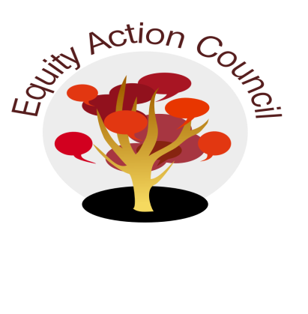
Time | Process | Topic | Facilitator(s)
2:00pm | I | I. Introduction: Welcome and Check in With Participants | Alicia Cortez
2:05pm | D | II. President Search Discussion – Website with Final Candidates | Melissa Aguilar
2:30pm | I | III: Equity Champion Awards Update – Nomination Form | Erick Aragon
2:40pm | I | IV: Emergency Fund for Students - Website | Lisa Mandy, Director of Financial Aid
2:55pm | I/D | V. Student Wage Policy | Genevieve Kolar, DASB Trustee
3:10pm | I | VI. EAC Governance Structure - Survey | Alicia Cortez
3:20pm | D | VII. Announcements  - Upcoming Equity Trainings  - Equity Certification Training for Classified Professionals  - Student Voices for Change | Erick Aragon
3:25pm | D | VIII. Appreciations | All

EAC Community Agreements
Show up, and choose to be present
Pay attention to what has heart and meaning
Tell the truth without blame or judgment
Be open to outcome, not attached to outcome
From The Four-Fold Way® by Angeles Arrien, Ph.D.

